**Write a program to rotate an object by 90 degree in clockwise direction**

#include<graphics.h>

#include<stdio.h>

#include<conio.h>

#include<math.h>

int main()

{

int gd=DETECT,gm;

int pivot_x,pivot_y,x,y;

double degree,radian;

int rotated_point_x,rotated_point_y;

initgraph(&gd,&gm,"C://TURBOC3//BGI");

cleardevice();

printf("\t\t*********** ROTATION *********** \n");

printf("\n Enter an initial coordinates of the line = ");

scanf("%d %d",&pivot_x,&pivot_y);

printf("\n Enter a final coordinates of the line = ");

scanf("%d %d",&x,&y);

line(pivot_x,pivot_y,x,y);

printf("\n\n Now, Enter a degree = ");

scanf("%lf",&degree);

radian=degree*0.01745;

rotated_point_x=(int)(pivot_x +((x-pivot_x)*cos(radian)-(y-pivot_y)*sin(radian)));

rotated_point_y=(int)(pivot_y +((x-pivot_x)*sin(radian)+(y-pivot_y)*cos(radian)));

setcolor(RED);

line(pivot_x,pivot_y,rotated_point_x,rotated_point_y);

getch();

closegraph();

return 0;

}

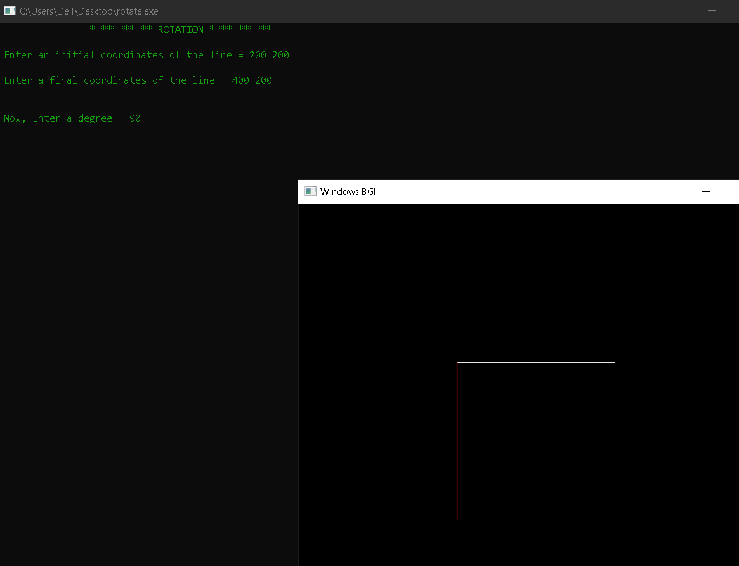

**Write a program to draw a line using Bresenham’s line generation algorithm.**

#include<stdio.h>

#include<graphics.h>

void drawline(int x0, int y0, int x1, int y1)

{

int dx, dy, p, x, y;

dx=x1-x0;

dy=y1-y0;

x=x0;

y=y0;

p=2*dy-dx;

while(x<x1)

{

if(p>=0)

{

putpixel(x,y,7);

y=y+1;

p=p+2*dy-2*dx;

}

else

{

putpixel(x,y,7);

p=p+2*dy;}

x=x+1;

}

}

int main()

{

int gdriver=DETECT, gmode, error, x0, y0, x1, y1;

initgraph(&gdriver, &gmode,NULL);

printf("Enter co-ordinates of first point: ");

scanf("%d%d", &x0, &y0);

printf("Enter co-ordinates of second point: ");

scanf("%d%d", &x1, &y1);

drawline(x0, y0, x1, y1);

getch();

closegraph();

return 0;

}

**Write a program to implement Boundary-fill algorithm.**

#include <graphics.h>

void boundaryFill4(int x, int y, int fill_color,int boundary_color)

{

if(getpixel(x, y) != boundary_color &&

getpixel(x, y) != fill_color)

{

putpixel(x, y, fill_color);

boundaryFill4(x + 1, y, fill_color, boundary_color);

boundaryFill4(x, y + 1, fill_color, boundary_color);

boundaryFill4(x - 1, y, fill_color, boundary_color);

boundaryFill4(x, y - 1, fill_color, boundary_color);

}

}

int main()

{

int gd = DETECT, gm;

initgraph(&gd, &gm, "");

int x = 250, y = 200, radius = 50;

circle(x, y, radius);

boundaryFill4(x, y, 6, 15);

delay(10000);

getch();

closegraph();

return 0;

}

